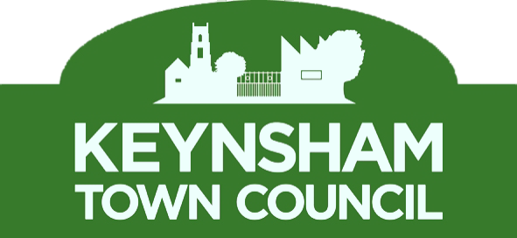
Bad Debt Policy

1. Introduction
This policy outlines Keynsham Town Council’s procedures for dealing with late payments and outstanding accounts (bad debts) in accordance with Financial Regulations.

2. Policy Objectives
The aim of this policy is to make clear the procedure that Keynsham Town Council will follow to identify, minimise and recover potential bad debts and write off any debts which cannot be recovered.

3. Credit Control
All income due will be collected in accordance with Financial Regulations and any sums found to be irrecoverable or any subsequent bad debts shall be reported to the Finance & Policy Committee and Full Council.

Unpaid income and bad debts shall be treated in the following manner:
- Invoices which remain unpaid after 30 days will receive a telephone call or email reminding the customer that the invoice remains unpaid.
- Invoices which remain unpaid after 45 days will receive a letter reminding the customer that the invoice remains unpaid.
- Invoices which remain unpaid after 60 days will receive a letter reminding the customer that the invoice remains unpaid and that the Town Councils’ financial information, including bad debts, is reported to Council and published on its website.
- Invoices which remain unpaid after 90 days will receive a letter reminding the customer that the invoice remains unpaid, that the Town Councils’ financial information, including bad debts, is published on its website and notifying of the withdrawal of the service provided. This letter will also include a statement that Keynsham Town Council reserves the right to pursue all outstanding debts through the legal system.
- All letters will be accompanied by a statement of account from the Town Council’s financial system.

4. Write off bad debts
Keynsham Town Council will seek to minimise the cost of write offs by taking all necessary action to recover what is due. Debts will be subject to the full recovery, collection and all reasonable legal procedures.

The Town Council recognises that where a debt is irrecoverable, prompt and regular write off of such debts is good practice. Whilst writing off bad debts is a non-routine function; all practical means should be taken to recover outstanding amounts due to the Town Council before the RFO recommends writing off a bad debt to the Finance & Policy Committee. Before this decision is made, due diligence consideration should include the following: -

- The cost of recovery against the amount owed.
- The likelihood of success.
- Were the correct credit control procedures followed.
- Could procedure and practices be improved.

Any debts to be written off should be reported in the form of a write off schedule to the Finance & Policy Committee, for recommendation to full Council who may approve the write off of bad debts. The write off schedule should contain the following information:

- Customer Reference.
- Invoice number.
- Date of invoice.
- Amount of debt.
- Reason for write off.
- Recovery history.
- Date of write off.
- Authorisation of write off.

5. Year-end write offs
The RFO should ensure any bad debts and doubtful debts are correctly accounted for at year end.

Adopted:
Review Date:

