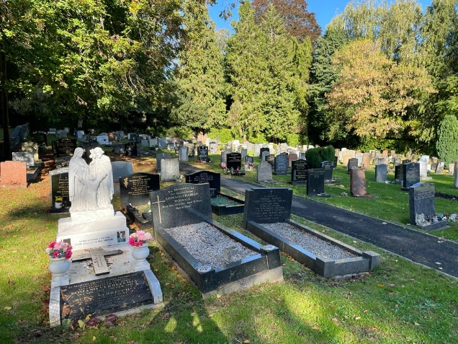

Visitors are requested to abide by the Cemetery rules which exist to provide for the quiet and peaceful enjoyment of all.

· A Toilet is situated in the archway by the Chapel, Open 9-4 Monday to Friday.

· Water is provided from a tap at the back of the Chapel and from the water butt in the new extension, Watering cans are also provided. Please return them after use.

· Dogs must be kept on leads at all times and remember to use the dog bins provided.

· Smoking is prohibited in the Cemetery.

Durley Hill, Keynsham BS31 2AJ

Keynsham Cemetery

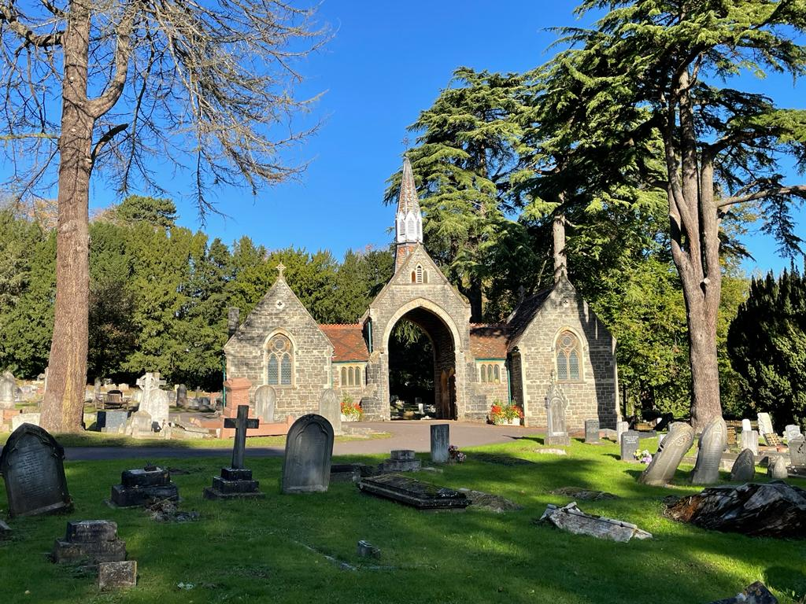

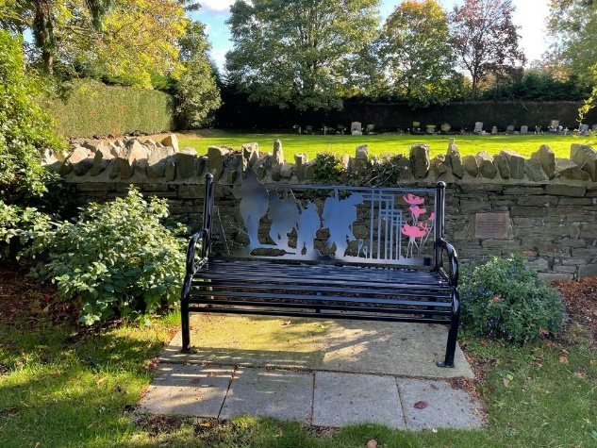

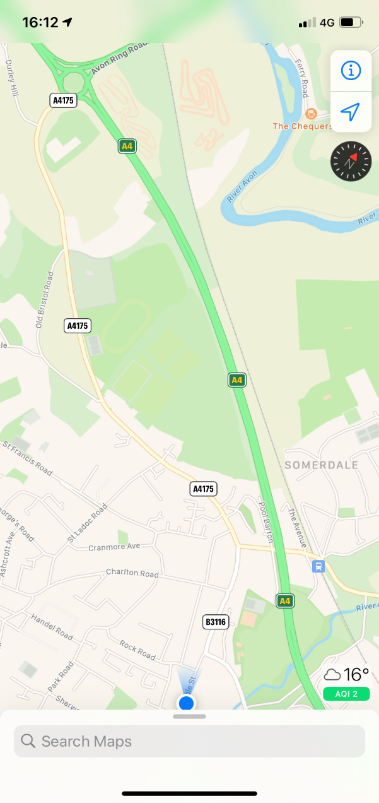

Keynsham cemetery

A Guide for people using and visiting.

Keynsham cemetery

**Keynsham Town Council, 15-17 Temple Street,**

**Keynsham, Bristol, BS31 1HF**

**0117 986 8683**

**townclerk@keynsham-tc.gov.uk**



**www.keynsham-tc.gov.uk**

**office open 9-12:30pm Monday - Friday**

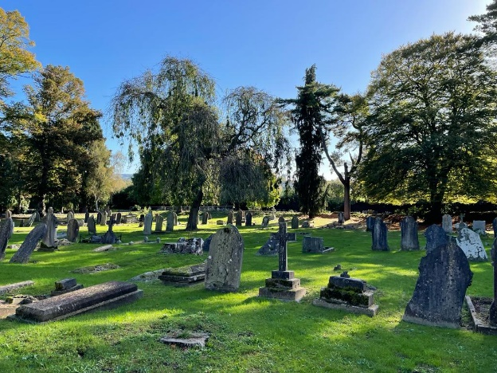

**Arranging A Burial**

· Your Funeral Director will usually make all the necessary arrangements with the Town Council and have all the necessary paperwork.

· We require three clear working days (excluding the day of request and the day of the burial) in order to allow for all arrangements to be properly completed.

· The normal time for burials to take place are between 10.00 a.m. and 3.00 p.m. from Monday to Thursday (1 p.m. Fridays). Burials may not take place on Saturdays/Sundays, or on Bank Holidays.

· Vases must be made of natural quarried materials and must not exceed 12” in any dimension. Glass and plastic vases are not permitted and will be removed from the graves.

· Our regulations are intended to ensure the safety of our Cemetery staff; broken items can be caught in machinery and hurled for some distance causing danger to all.

· Artificial flowers may be placed in the Garden of Remembrance as long as they are in approved granite/marble vases. Where any flowers show sign of deterioration they will be removed so as not to distract from the general appearance of the garden.

· All memorials of any description permitted in the Cemetery shall be so erected and remain at the sole risk of the owner and the Council shall not be held responsible for any damage or breakage which may occur through any cause.

· Graves tend to subside over a period of time. As they settle our Cemetery staff will re-level the affected areas.

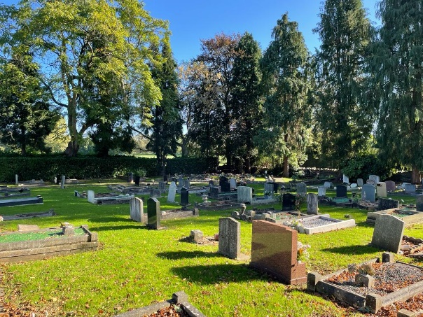

· Details of the deceased person need to be provided on the Town Council’s Interment Form.

· A plan of the Cemetery, showing the position of every grave, is kept at the Council office and may be inspected during office hours, together with a copy of the full rules and regulations relating to the Cemetery and a copy of the fees and charges and record books of burials.

**Exclusive Right Of Burial**

· An Exclusive Right of Burial (50 years) must be purchased before a burial can take place or a Memorial Stone erected.

· If the Right has been previously purchased the certificate must be produced to the Council, or if it cannot be produced an indemnity form completed in order for the grave to be re-opened.

· It is the responsibility of the purchaser of the grave to inform the Town Council of a change of address.

· No pre-purchasing of graves is permitted.

· Burial fees for non-Keynsham residents are higher than the standard fee for purchase of plots and burials.

· Charges are levied for purchases of Exclusive Rights of Burial and for Interments separately, hence a Keynsham resident can purchase a grave to bury a non-Keynsham resident and vice-versa, and the appropriate In Parish and Out of Parish fees apply.

· the cemetery is a active working cemetery so it is possible that on occasion Graves may need to be covered by a soil box if an adjacent grave space is being dug this is completely normal and will only last a few days until the soil is backfilled

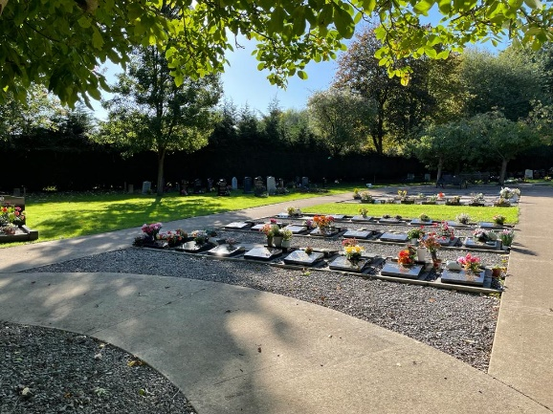

**Types of plot**

· A Lawn Plot is laid to lawn and a headstone, one vase and flowers only allowed at the top of the grave.

· A Kerb Plot allows full kerb surround, headstone and planting.

**Single Burial— depth 6ft.**

**Double burial— depth 6ft & 4ft.**

**Triple Burial—depth 8ft, 6ft & 4ft**

Ashes can be scattered over a grave or in the Garden of Remembrance or a casket of ashes can be interred in a Lawn or Kerb plot on in the Memorial Garden section which is set aside for caskets of ashes

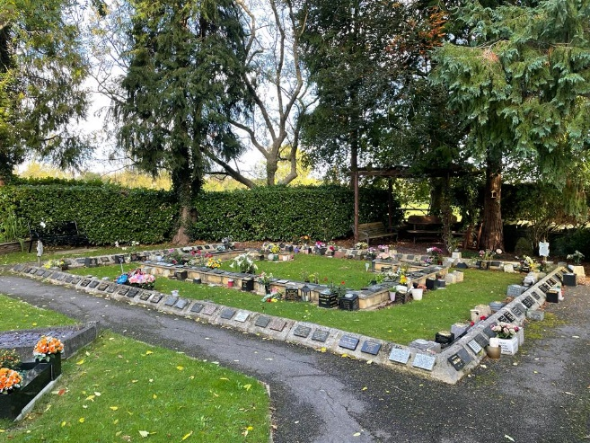

**Maintenance Of Graves & Memorials** Cemetery & Garden of Remembrance

· Memorials on graves require permission from the Town Council and must be fitted to NAMM Standards (National Association of Memorial Masons).New and re-installed memorials will be tested after six months, one year and thereafter every five years. Grave owners may be present at the testing if they so wish.

· Only memorials permitted by the Council are allowed in the Cemetery and Garden of Remembrance and any unauthorized items including toys and ornaments may be removed, without prior notice, by our Cemetery staff.

· All permitted memorials shall be kept in repair and good condition by the owners.

the cremated remains plots (2ft x 2ft) within the new extension Memorial Garden provide an attractive quiet area to inter two caskets of   
cremated remains into a plot surrounded by a stone   
edging. A polished, black or dark grey desk tablet (18ins x 18ins), which will include a flower holder, can be purchased from a memorial mason to go on top of the base slab.